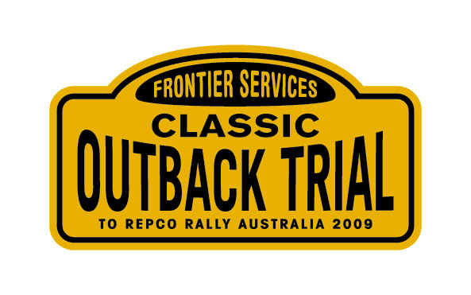

Classic Outback Trial
Photo memories
ORDER FORM

Please supply high resolution image of photo number ………….. @ $30.00
Please supply high resolution images of photo numbers (1)……… (2)……… (3)…….. @ $60.00
Please supply all high resolution images on DVD of car number ………….. @ $110.00
View images at: www.jep.net.au
Please supply the commemorative DVD Qty: 1 @ $50.00
Please supply the commemorative DVD Qty: 2 @ $35.00 each
Please supply the commemorative DVD Qty: 3 or more @ $25.00 each
Total amount $...............

All prices include GST, Express registered mail and packaging
Name: ………………………….…………………………………………………………….
Postal address: ………………………………………………………………………………
Suburb: ………..…………… State: ……………. P/Code: ……………
Payment details :
Cheque enclosed

Direct deposit (tick applicable)

Email orders: pora1@bigpond.net.au
Monies may be paid by cheque made payable to “Classic Outback Trial Pty Ltd”
and mailed to: Classic Outback Trial Pty Ltd
Unit 1, 533 Whitehorse Road SURREY HILLS VIC 3127,
or
direct deposit to:
NAB Classic Outback Trial Pty Ltd
BSB No: 083 121 Account No: 831438345

